The following are instructions on how to create the Prospect Label report via Crystal Reports. The following steps should be followed.

- Double click on the report icon from Windows Explorer.
- When it opens, you should see a screen as shown below.

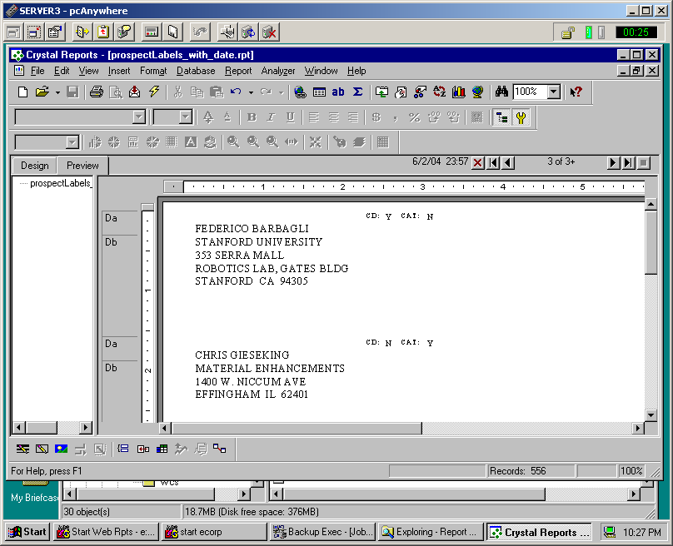
- To run the report, click the yellow “lightning bolt” icon as shown in the toolbar above.
- You should next be prompted for filtering criteria for the report as shown below. Choose the “Prompt for new parameter values” option.

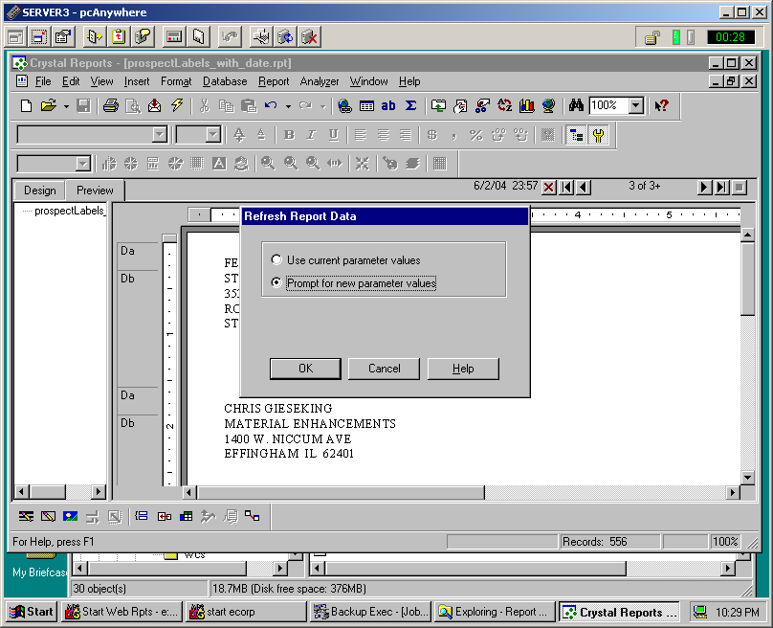

5. Next, enter a beginning and end range for the Prospect Ids as shown below. It is possible to choose only the beginning range by selecting the “No Upper Limit” option.
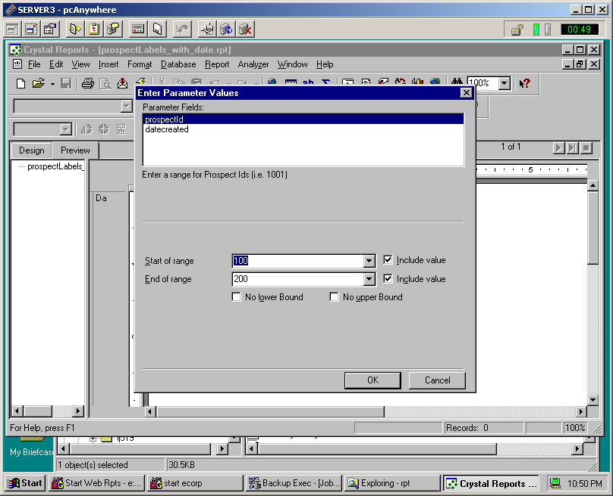

6. Next specify the Date Created filtering criteria as shown below. This will include all Prospects created since this date.
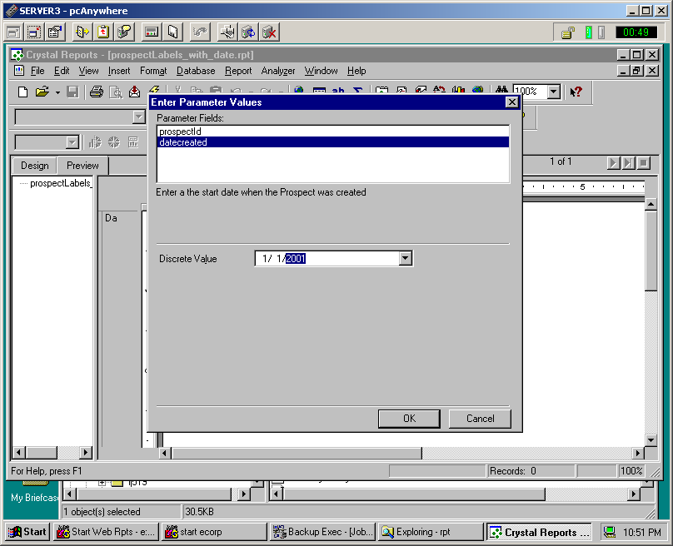

7. After pressing “OK”, you will be prompted for the database connection user Id and password. You should use “daimgr” as the password.
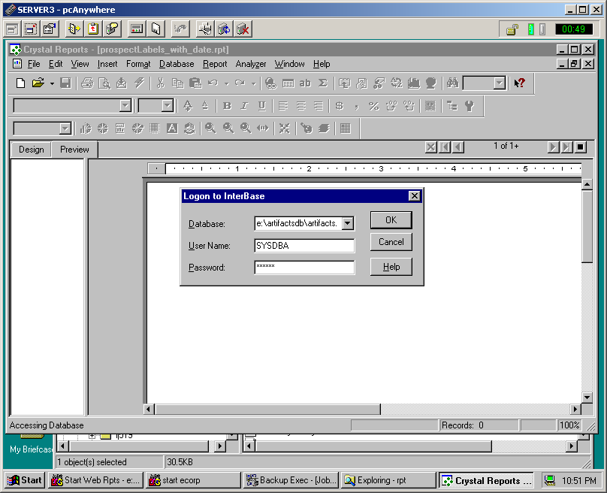

8. Finally this will produce the report shown below. Be sure to connect to the correct printer before printing.
